User guide

# Login page

When firstly accessing the application, the user is shown the following page:

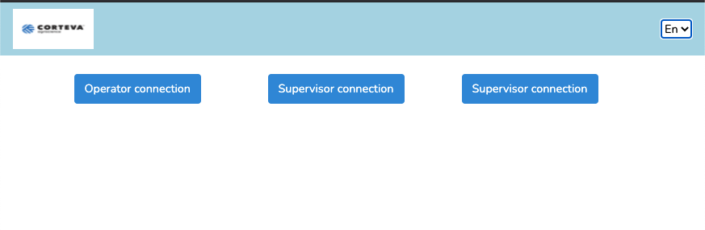

Image - Connection Page

Through this page, the user can connect to the application accordingly to its credentials, that could be, **operator**, **supervisor,** or **administrator**. Each credential will allow the user to access specific functions within the application. A user is identified by its username and password combination. Also, in this page the user can select the application’s language using the dropdown menu in the top right corner.

# Operator interface

When connected as an operator, the user is led to the following page:

Image - Operator Interface

The user must select firstly a crew leader and team type, the start and end times will be auto filled. Next, he must fill in the GMID code and Production Order number for each production line appearing at the bottom of the page. Click on OK button to validate, the user is taken to the following page.

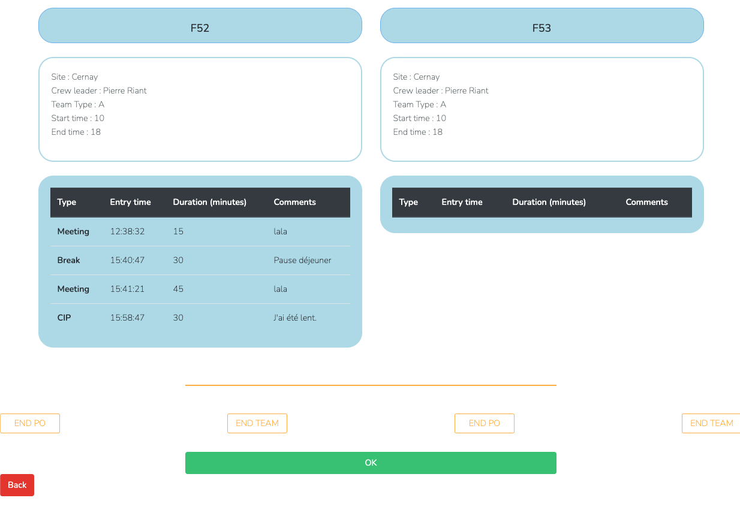

Image 3 - Operator interface when crew type, team leader and start and end timer are entered

In this page a column for each production line is shown. Each column includes a recall of information entered in the previous page and a table with the events concerning the production line. By clicking the button containing the name of the production line, on top of each column, the user can add an event.

At the bottom of each column, the user can end the production line or the team using the buttons and then clicking the OK button.  
When adding an event, the user is taken to the following page:

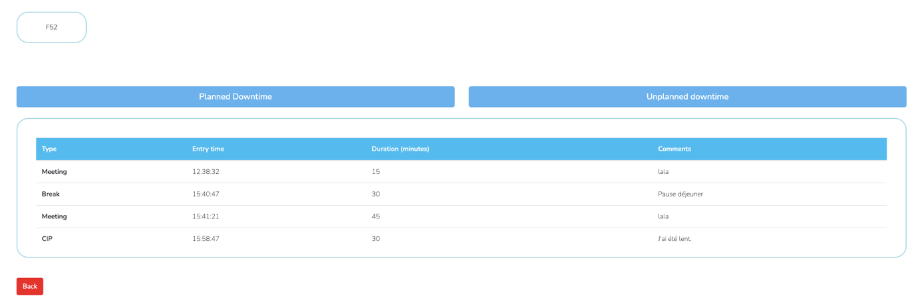

Image 4 - Operator interface, event adding

On this page the user can create planned and unplanned downtime events by clicking the respective buttons on the top. He has then the option to choose from predefined events, for each event, specific information might be needed and entered by the operator.

Back to the production line summary, when ending a PO, the user must enter information about the PO on the following page:

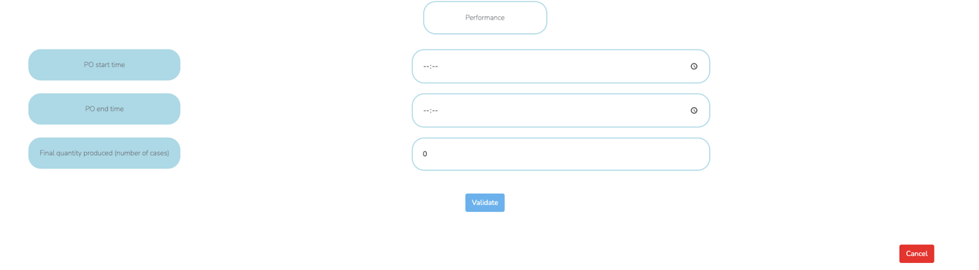

Image - Operator interface, PO ending

Clicking the validate button shows a summary of the closed PO:

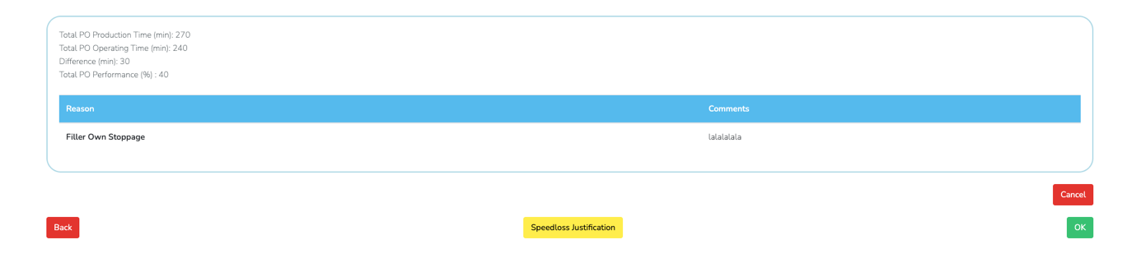

Image 6 - Operator interface, PO ending validation

Once the summary is calculated, the operator may justify a difference between the production time and operation time, by clicking the **Speed Loss Justification** button. The user is taken to the following page:

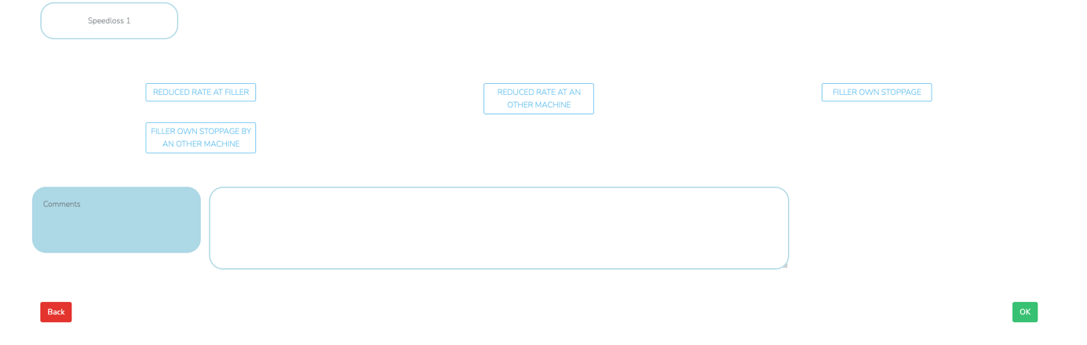

Image 7 - Operator interface, PO ending speedloss justification

In this page the user can select the speed loss reason between **reduced rate at filler**, **reduced rate by another machine**, **filler own stoppage** and **filler own stoppage by another machine**. He can eventually write a comment to explain the event. To validate click the **OK** button on the bottom right corner.

# Supervisor interface

When connected as a supervisor, the user has access to the following functions, which can be select through the dropdown menu on the top right corner.

## Packaging Line ID

On the left section of the page, a diagram representing the organization of machines in the production line, a red arrow means a phase where it could be a rejection. On the right section, two tables summarize information about the machines and production formats of the selected production line.

## Downtime Report

This function allows the user to consult the downtime report of the chosen product line and in a chosen date interval. The report includes, on the left, a list of planned downtimes, unplanned downtimes, and speed losses, with its durations.

On the right, two pie charts represents the form volume split and the pack size split for the chosen production line and date, and graphic information about the data in the tables. At the bottom of the page, indicators on availability, performance, quality and OLE are shown.

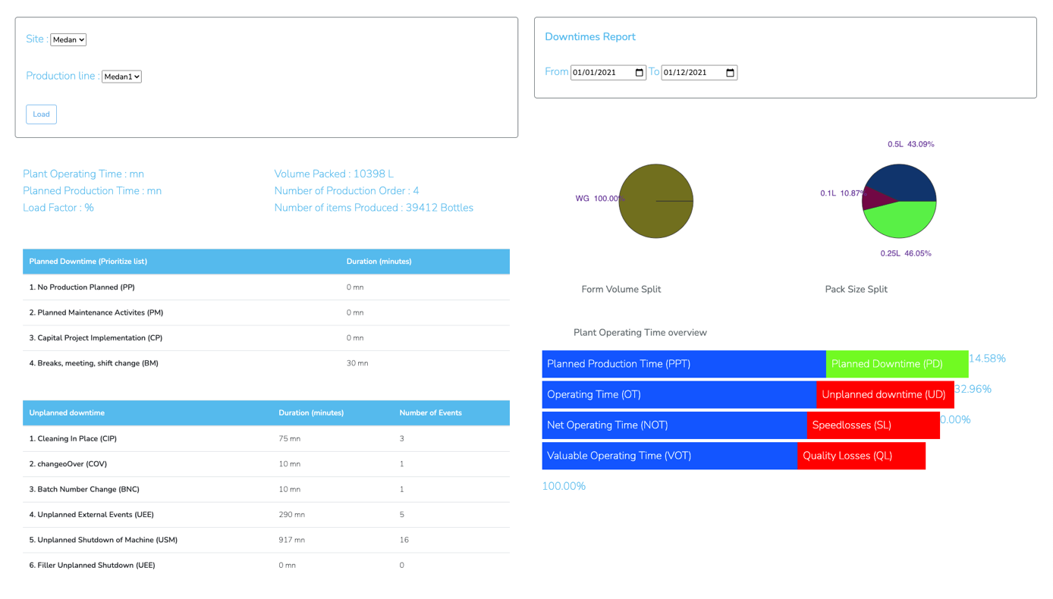

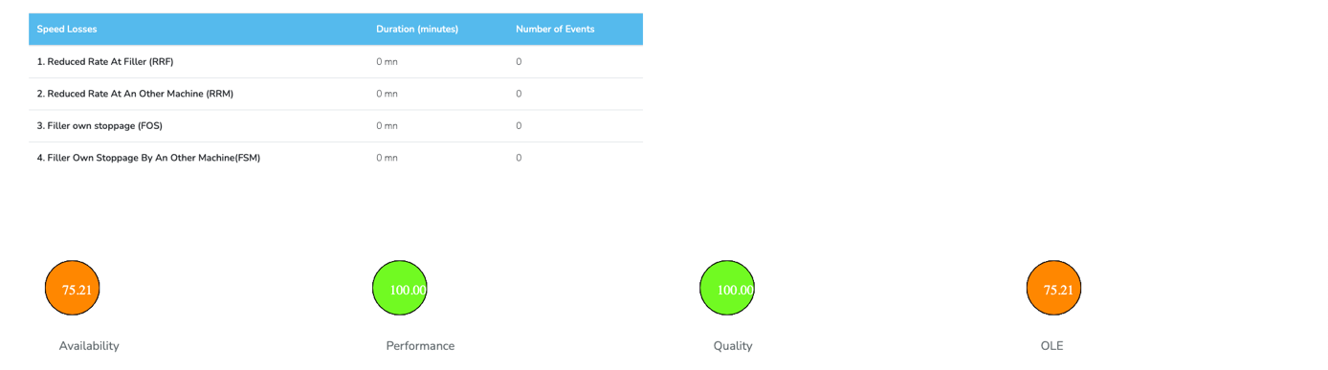

Image - Supervisor interface, downtime report page

## Quality Losses Dashboard

This page summarizes the objects produced by machine and by format and shows the quality loss coefficient.

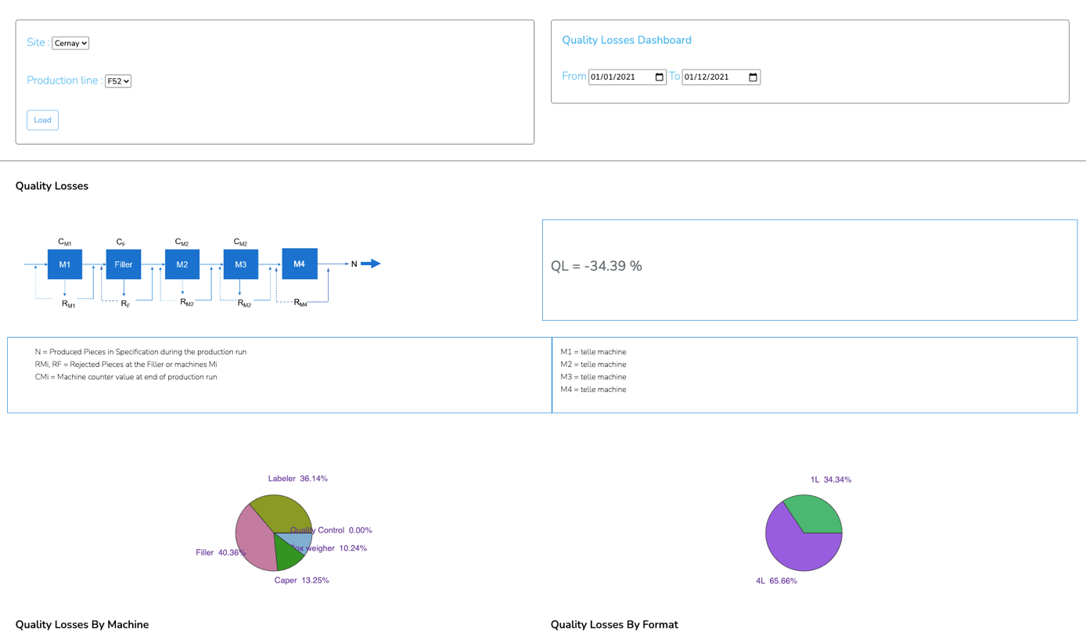

Image 9 - Supervisor interface, quality losses dashboard

## Production Dashboard

This page shows production data from a selected production line and in a selected data interval. To see the date, the user must select a site, production line and the date interval in the upper portion of the page.

## 

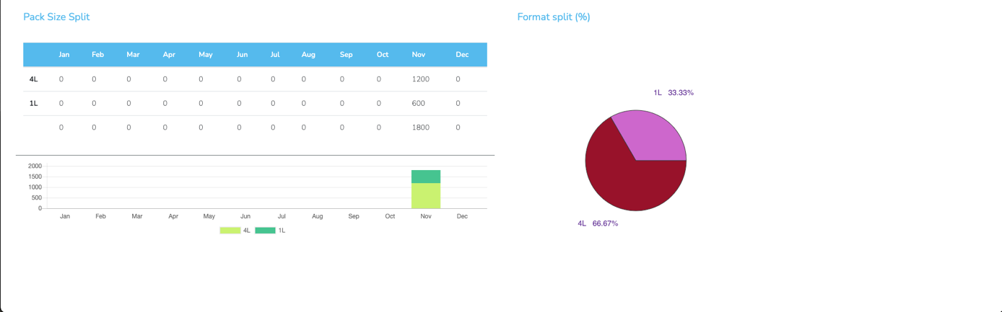

Image - Supervisor interface - production dashboard

## Overall Line Effectiveness

This page shows information about the effectiveness of a production line in a selected year. Indicators of performance, availability and quality are shown in a graph. Moreover, a table containing indicator trends versus the previous year is shown to give the user an idea about this indicators’ evolution over the previous year.

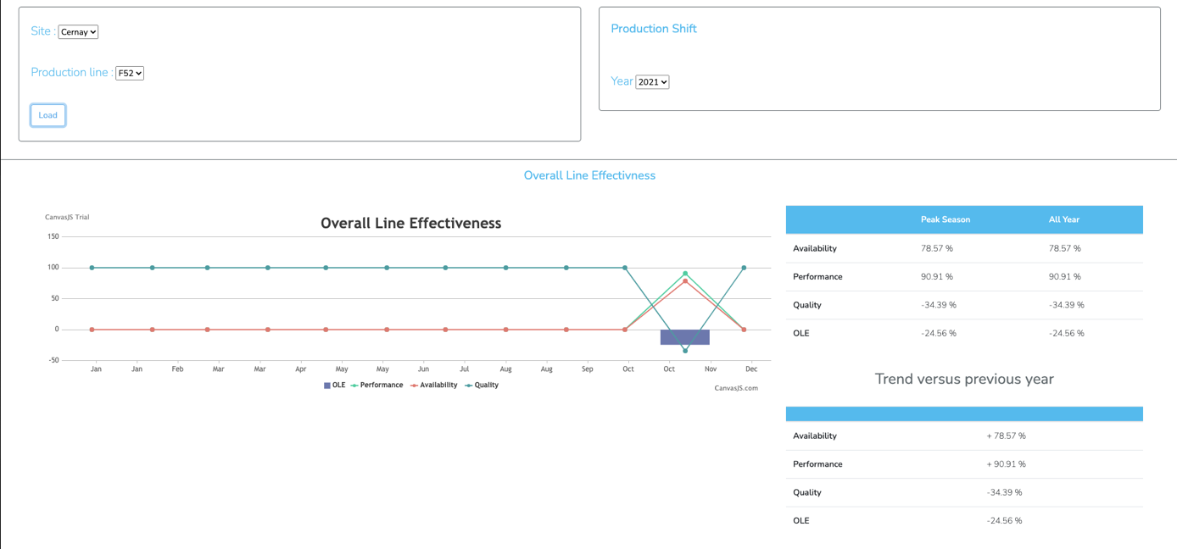

Image 11 - Supervisor interface, overall line effectiveness

## Unplanned Downtime Dashboard

This page shows different data about unplanned downtime events, which are of type **Cleaning in Place (CIP)**, **Change-Over (COV)** and **Batch Number Change (BNC)**.

To visualize the data the user must first select a site and a production line, all data shown in the page will concern that selection.

The upper portion of this page’s interface shows unplanned events related data, concerning the current year. A table shows **CIP**, **COV** and **BNC** events numbers and durations for each month of the current year. A frame next to the table shows synthetic yearly data for each event category, including total duration, number, and average duration. At the bottom of this section three graphs show the number of events of each category broken down into 10-minute intervals, as well as the percentage of the yearly duration of each event compared to the total duration of unplanned downtime, again with respect to the current year.

Image 12 - Supervisor interface, unplanned downtime dashboard, upper portion

The bottom portion includes a production window, where the user can select custom dates to filter the data. Within the production window, a table shows the total number and duration of each downtime category with respect to the selected dates. Still in this portion, one table shows duration, number, average duration, and standard deviation of each CIP sequence. Another table shows the same information about COV volumes. As with the previous section, all data concerns the selected production line.

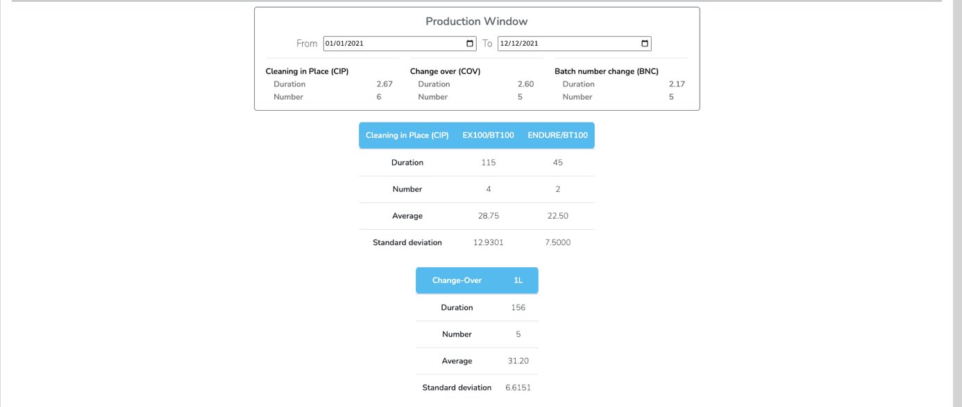

Image 13 - Supervisor interface, unplanned donwtime dashboard bottom portion

## Unplanned Downtime Shutdowns

This page shows different data about unplanned downtime shutdowns, which can be of type **machine shutdown** or **external shutdown**. To visualize the data, the user must first select a site and a production line.

The left section of the page regroups data concerning machine shutdowns. A graph shows, by machine, the total duration and number of shutdowns, during the current year. A table show, by machine, the total duration, total number, and average duration of shutdowns. The same information is shown for the subcategory reason of shutdown, for each machine. Finally, for each reason of shutdown, the same information is shown for each commentary, producing a synthetic vision of all the shutdowns. The percentage of machine shutdowns compared to the total shutdown downtime is also calculated and shown at the bottom.

The tables’ structure looks like this:

|  |  |  |  |
| --- | --- | --- | --- |
| Machine Shutdown | Total downtime | Frequency | Average duration |
| *MACHINE 1*  *REASON 1*  *COMMENT 1*  *COMMENT 2*  *REASON 2*  *COMMENT 1* | 100  60  15  45  80  80 | 5  4  1  3  1  1 | 15  15  15  80  80 |

Table 1 - Unplanned downtime shutdowns, table structure

The right section follows the same structure, but for external shutdowns. This time, the table only shows information about the cause of the external shutdowns, which are predefined regardless of the real cause.

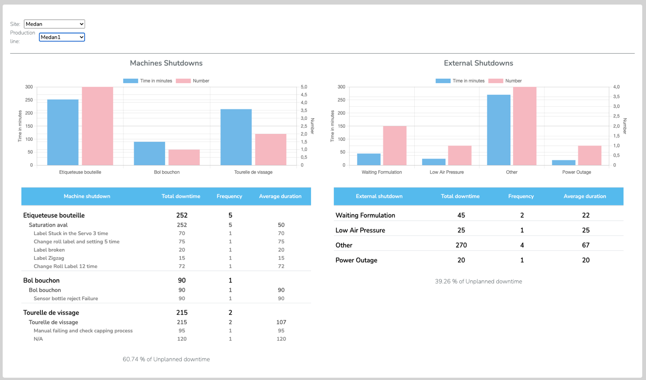

Image 14 - Supervisor interface, unplanned downtime shutdowns

## Unplanned Downtime Speed Losses

This page shows data about unplanned downtime speed losses, which can be of type **filler own stop** or **reduce rate at filler**. To visualize the data, the user must first select a site, a production line and a date interval using the menu at the top of the page.

For each of the types, a table containing **Production Order**, **Format**, **Design Rate**, **Reduce Rate**, **Wasted Time**, and **Comment/Reason**. Also, graphs showing total time and number for the subtypes **filler own stop** and **filler stop by other machine**, and **reduce rate at filler** and **reduce rate at filler due to another machine capacity** downtimes are shown.

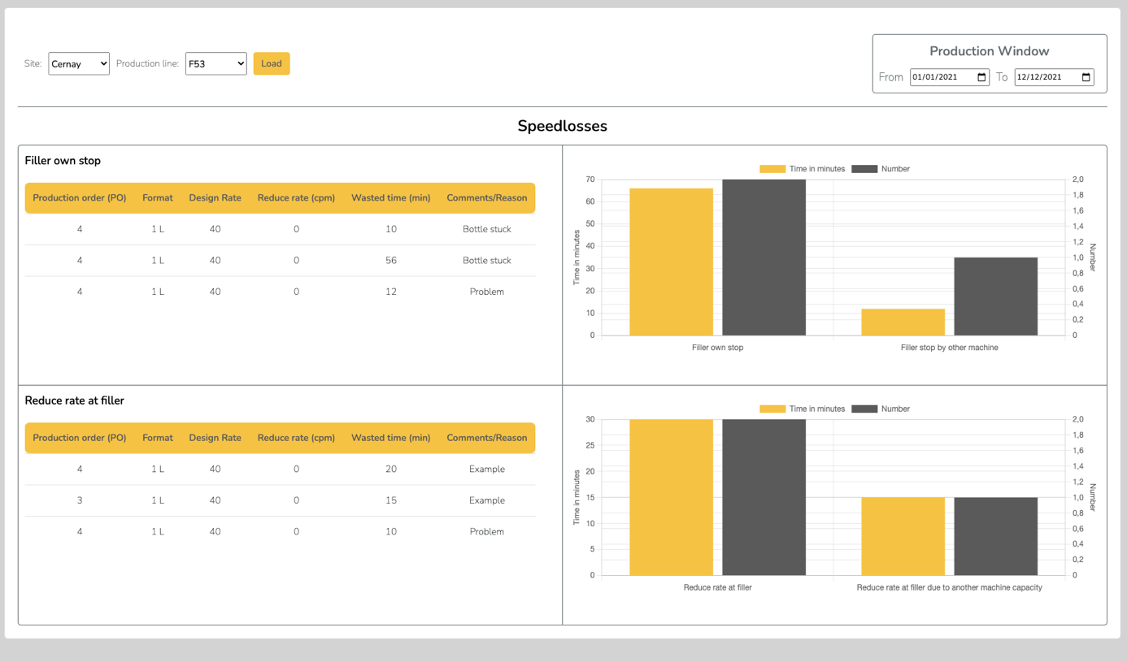

Image - Supervisor interface, speed losses

# Inserting data into the application’s database

To insert data into the application’s database you have the option to use a .csv file to add large amounts of data at once. EXPLIQUER COMMENT ACCEDER A PHPMYADMIN.

In the *phpMyAdmin* page,